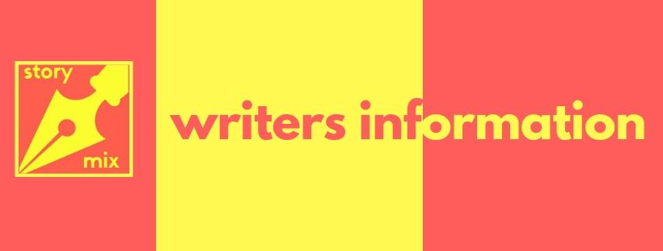
About Us:
Storymix is a fiction production company with a focus on more inclusive representation in children's books. We craft stories with diverse casts, fantastic worldbuilding and exciting plots.
Currently, STORYMIX is concentrating on working with with writers and illustrators of colour. In 2017 only 2% of British children’s book creatives were of BME origin – in our view that number is far too low.
Our studio works with creatives at all stages in their careers, be they published, self-published, unpublished, agented or unagented. STORYMIX owns all the rights to the concepts developed and writers and illustrators are paid to sample, and receive an advance and a share of the royalty for each book published.
Creatives will also learn about the business of publishing through us and our long-term ambition is that writers and illustrators of STORYMIX projects will also go on to secure additional publishing deals with their own ideas and meaningfully change the publishing landscape

About You:
It doesn’t matter if you have been a writer for many years or are just starting out. What does matter is that you love telling stories and have an engaging voice that would be appealing to children.
If you are a poet wishing to write prose for children then we are excited to read your work. Similarly, we are very interested in playwrights and screenwriters who wish to write prose for children. If you are a journalist, songwriter or indeed anyone who loves writing get in touch.
We ask for a sample of work so we can get a sense of your voice and see if there is a current project in development that might be a match. If this is the case, we may ask you to write or illustrate a sample of work based on the STORMIX concept. All creatives who get in touch will be added to our database as new projects are developed by STORMIX on a rolling basis.

To be added to our database, please attach a sample of your writing and the form below and send to storymixsubmissions@gmail.com

Guidelines for sample:
It can be the first ten pages of your novel, a collection of your poetry, songs or a sample of your screenplay or journalistic work. We like double-spaced, 12 point font, and page numbers. We prefer Word docs.
If you are an illustrator please feel free to send a link to a gallery of your work. If you are a writer and illustrator let us know and share examples of both elements of your work.

Writers Information Form
About You
First and last name:
Email address:
Telephone:

If applicable, please give us your website, Twitter, Instagram etc addresses:

Details of agent if applicable:

Short personal biography (no more than 50 words):

Short writing/illustrating CV (including books written or illustrated, writing or illustration seminars given or taken, any publication credits, fellowships or residencies, memberships in writing or illustrating organizations, etc):

Areas of Interest/hobbies/research/specialist knowledge/

How would you define your cultural identity?

How did you hear about STORYMIX?

